

Work Experience Directory

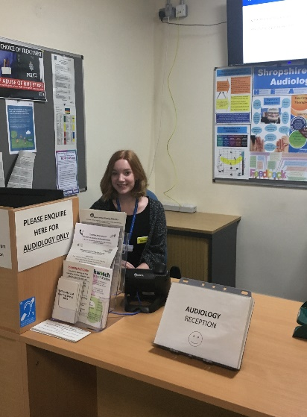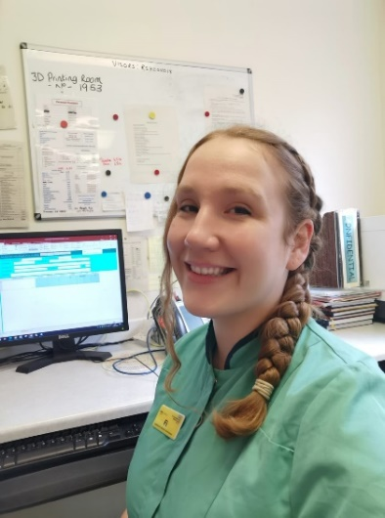

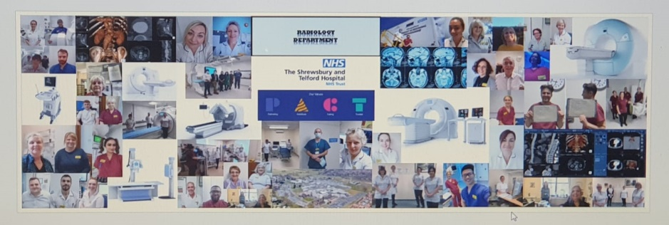

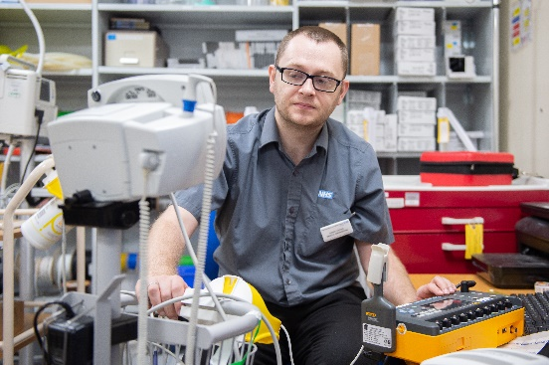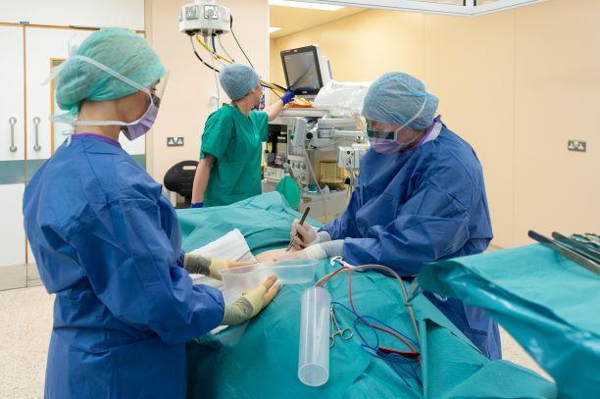
Work Experience Opportunities at SaTH
This directory provides an overview of the departments and job roles where the Trust offers work experience placements.
If you have a particular career interest that isn’t listed, feel free to get in touch with us at sath.wideningparticipation@nhs.net — we’ll do our best to advise you.
Please note that all work experience applications must go through our centralised application process. We’re unable to accept placements arranged directly with individual departments or staff members.
Due to high demand, we are only able to offer one placement per academic year. When submitting your application, please choose one department for your preferred placement and state the dates required for the placement
Placements are only available to those who live or who attend an educational establishment within Shropshire, Telford and Wrekin.
Once an application is received, we will liaise with the relevant managers to check availability. You can expect to hear from us within six weeks of applying. If you haven’t received a response after this time, please don’t hesitate to contact us sath.wideningparticipation@nhs.net
All departments included in this directory have been risk assessed and meet the requirements of the Trust’s Health and Safety Policy. Unfortunately, we are unable to offer placements in any areas that have not completed this process.
How to Apply for a Work Experience Placement

- Choose Your Area of Interest
Review this directory and decide which department or job role you’re interested in for your placement.
- Complete the Required Forms
Download and complete the Work Experience Application Form and Self-Declaration Form from either:
  - www.sath.nhs.uk
Go to - Working with us
Then - Work Experience
  - www.belongtosomething.co.uk
Go to – Find a Job
Then – Work Experience

- Submit Your Application
Email your fully completed forms to:
📧 sath.wideningparticipation@nhs.net
⚠️ Please ensure all sections of the application form are completed. Incomplete forms will not be processed or followed up.

For shadowing of doctors’ placement please see the timetable below regarding submission of application forms in relation to placement dates required.

Applications open | Placement dates 2025/2026
1st September – 31st October | January & February
1st December – 31st January | March, April & May
1st February – 31st March | June and July  Please note – there will be no placements available after 14th July 2026

Clinical services
Department | Placement information | Other information
Nursing | - 5 day observational only.  - Working with various members of the ward team | - Limited ward placements.  - Apply at least 8 weeks in advance.  - Year 12/Sixth form or above.
Pharmacy | - Placement duration: 1 day to 1 week.  - Rotate through each pharmacy team.  - Observe dispensing, stock management, ward rounds.  - Medication histories, patient interaction, discharge prep | - Year 12/Sixth form and above.  - Placements available in November and July.
Cardio-Respiratory technician | - All activities will be observational only.  - An insight into the career structure within cardio-respiratory  - Insight into how the department operates.  - An insight into heart and lung function testing using a variety of techniques and equipment. | - Year 12/Sixth form and above.  - Excellent communication skills
Fertility Services | - Placement duration: two days | - Year 12/Sixth form and above.  - Interest in healthcare science career.
Radiotherapy | - Placement duration: up to 1 week.  - During the placement you will gain an overview of radiotherapy treatment and the multidiscipline team that this entails. | - Year 12/Sixth form and above
Audiology | - Placement duration: maximum 3 days  - Observation placement with a mixture of adults/paediatrics services. | - Year 12/Sixth form and above  - Most suited to students who have a keen interest in science, technology but the main focus is patient interaction/communication
Radiology PRH and RSH | - Observational placement only  - Placement Duration: 2 days maximum  - An overview of the various areas and roles within the department | - Year 12/Sixth form and above
Maxillofacial | - Placement Duration: Up to a week in duration  - Participants will work in a lab setting taking part in various activities.  - Develop an understanding of the type of services supported and the training required to work within the department.
Medicine –  Shadowing a doctor | - Placement Duration: Placement length may vary on departments available.  - Shadowing a doctor(s) in a variety of settings within a hospital environment including clinics, ward work and if applicable theatres. | - Year 12/Sixth form and above
Midwifery | - Placement duration: 1 week.  - Shadow healthcare workers, or midwives if available.  - This experience will not be in the intrapartum (labour)  environment | - Year 12/Sixth form and above
Laboratories | - Placements may be available depending on activity within the department. | - Year 12/Sixth form and above
Therapies | - Work experience placements are available across the Therapy Centre including Dietetics, Physiotherapy, Occupational Therapy, Speech & Language & Admin and individual requests will be considered. | - Year 12/Sixth form and above
Theatres | - Placement Duration: Up to 5 days  - Participants will be able to observe the multi-disciplinary team in a variety of surgical specialities.  - They will have the opportunity to develop an understanding of the different roles of Theatre staff during the 3 phases of perioperative care (anaesthetics, surgery & post-op. recovery).  - This will also include an insight into the theatre career structure & potential development opportunities. Whilst on placement you will be fully supported. | - Year 12/Sixth form and above  - Placement experience may vary & is subject to change due to clinical activity, with some possible restrictions in place.

Support Services
Department | Placement information | Other information
Catering (RSH) | - Placement duration: 3 – 5 days.  - During the placement you will see the various departments within catering, patients meals/dining room servery/caffe bistro. | - Year 11 and above (Over the age of 15)
Legal Services | - Placement duration: 1-2 weeks.  - Support and observe work within the department. | - Year 12/Sixth form and above
Library Services RSH and PRH | - Placement duration: 1 day – 1 week  - During the placement you would:  - Take part in general library duties (shelving, issuing books, processing materials)  - Meet with members of the team to understand their role and responsibilities.  - Have the opportunity for involvement in more complex tasks.  - Learn about the role of libraries in a hospital environment. | - Year 11 and above.  - Participants should have good attention to detail and an interest in information (print & electronic)  - Must have some computer skills.  - No safety clothing required but should dress smartly.
Education Business Support Unit | - Placement duration: 1 day – 1 week  - Support with general business support e.g. scanning of health declarations, printing of course material, creating promotional posters.  - Observation of LMS systems, organising mandatory training programme.  - Opportunity to observe mandatory training sessions and other training taking place, observe lots of customer service, telephone and face to face support.  - Opportunity to develop their CV skills and interview guidance. | - Year 10 and above
Porters – PRH & RSH | - Duration of placement: no longer than 1 week. | - Year 10 and above
Improvement Team | - Placement duration: 1 day – 5 days maximum.  - Placements available throughout the year.  - Will participate in Improvement training (including bitesize videos), Improvement activities and Improvement planning meetings. | - Year 10 and above
Finance | - During the placement you will experience the day to day running of the department with an opportunity to spend time in financial management, financial accounts, payroll, accounts payable and accounts receivable teams.  - You will meet the members of the teams and understand their roles and responsibilities and have the opportunity to shadow finance staff in live meetings.  - You will gain an insight into NHS finance and undertake individual tasks such as data analysis. | - Year 10 and above  - Students with an interest in pursuing a career in NHS Finance.  - This placement will take place at the Shrewsbury Business Park and not one of the hospital sites.

